**LAB 2**

Id: 32

Name: Harshil Patel

**Part 1**

I created 3 pages login , registration , home page I have used bootstrap template for UI.

In home page I have use BCC news api to get news from the BCC news site . I provided two option for search based on topic and also source.

I have implemented angular js script for home page.

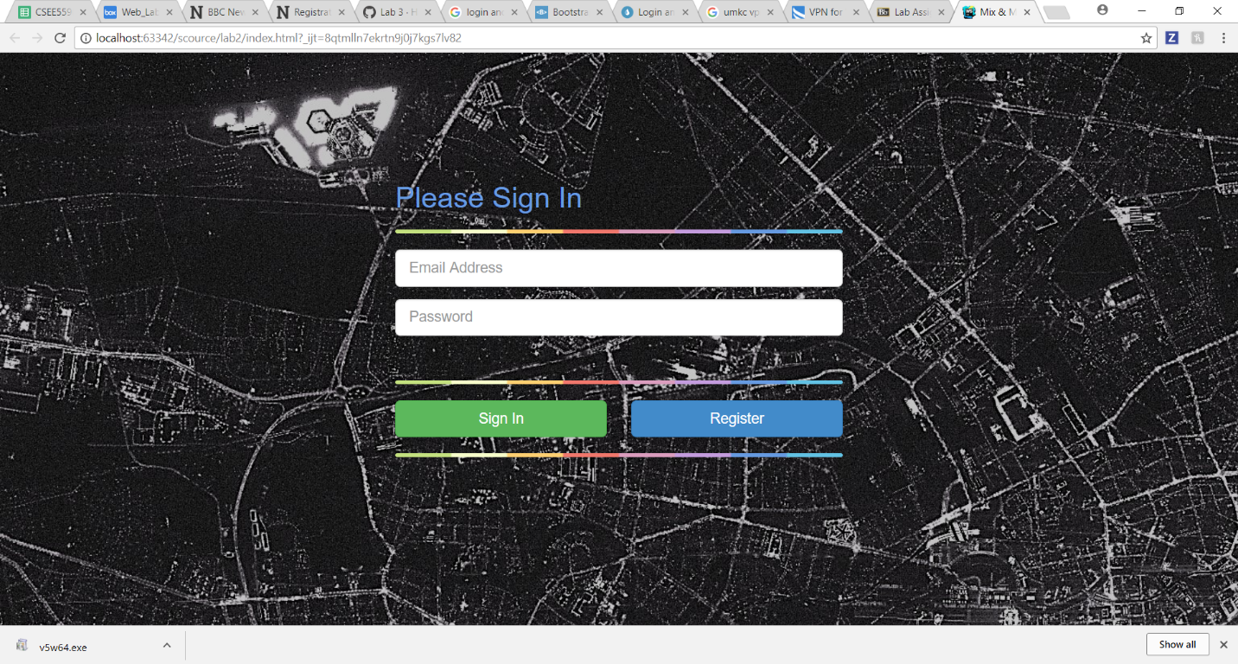

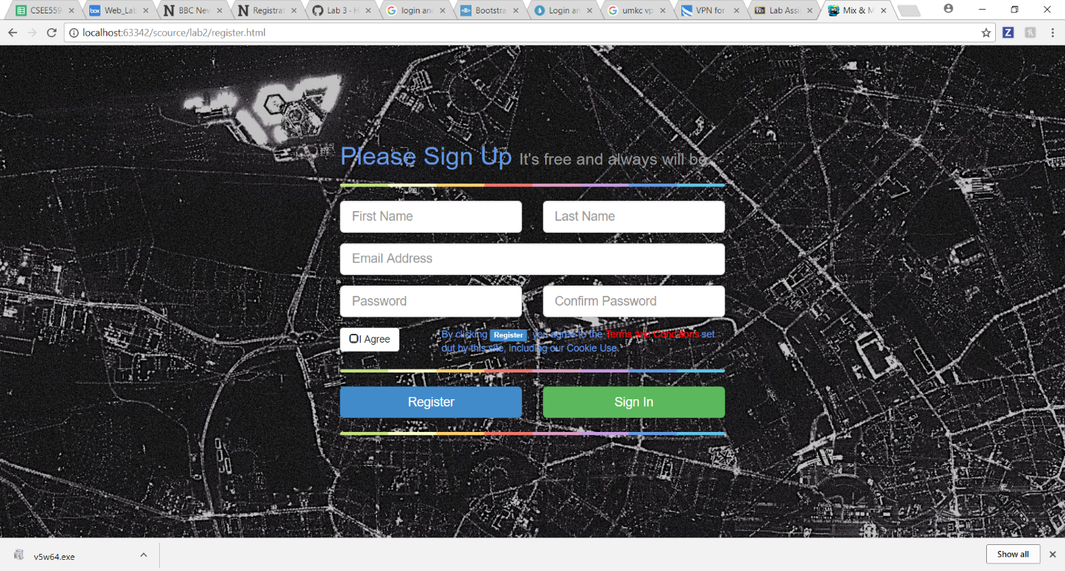

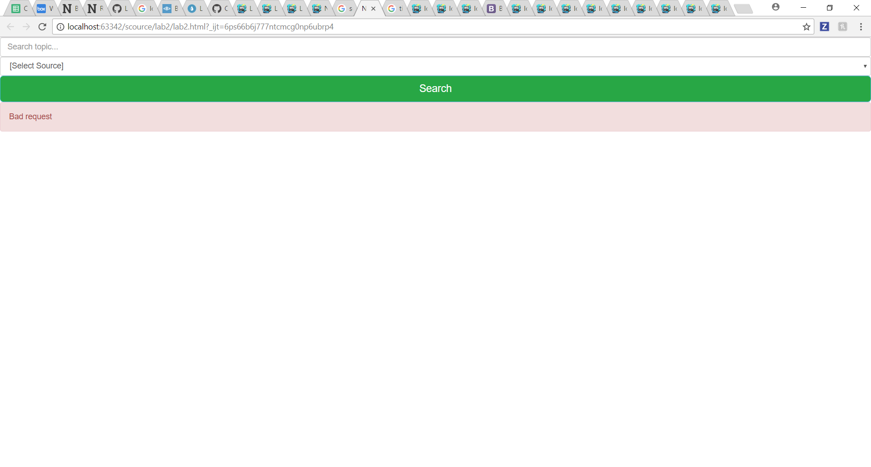

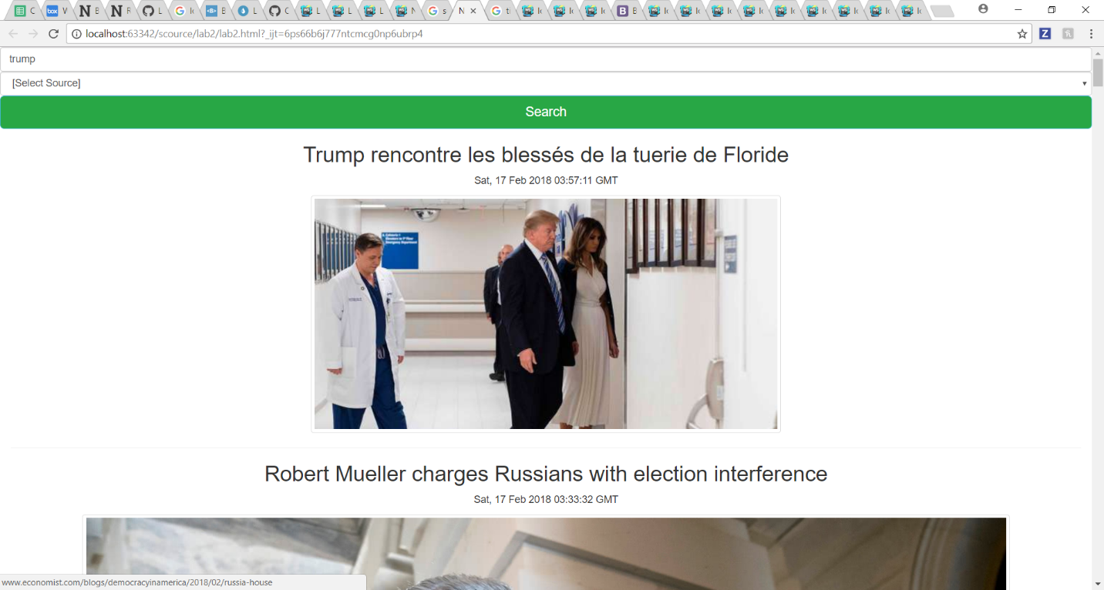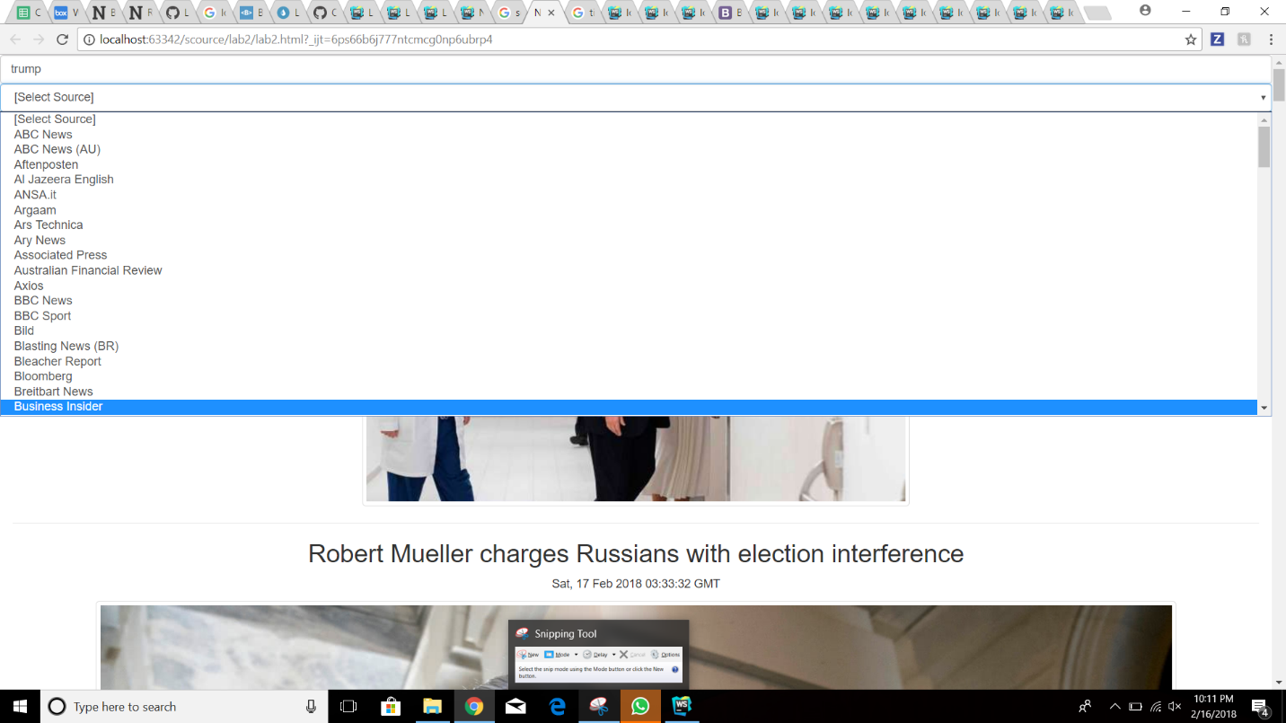

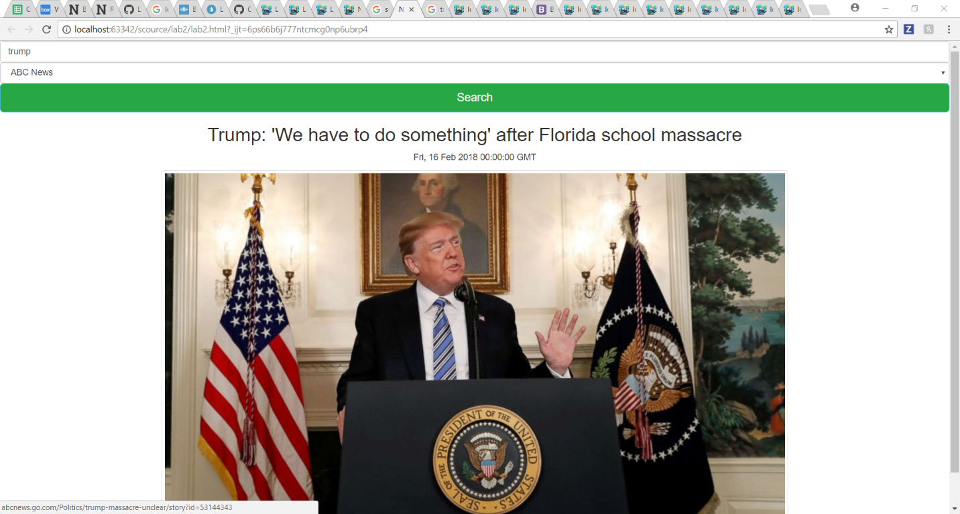

**Part 2**

Tic -tac toe

I have crated js file in which I have created method that will be called when button will be clicked.

And it will contain all the logic.

